**Advance DevOps lab**

**Experiment 9**

**Name: BALOCH MUZAMMIL HAFEEZ ROLL NO: 612012**

**Semester: V**

**Branch: Information Technology**

1. **Install docker on AWS EC2 –Ubuntu by using curl.**

Step 1: Launch an Ubuntu EC2 instance.

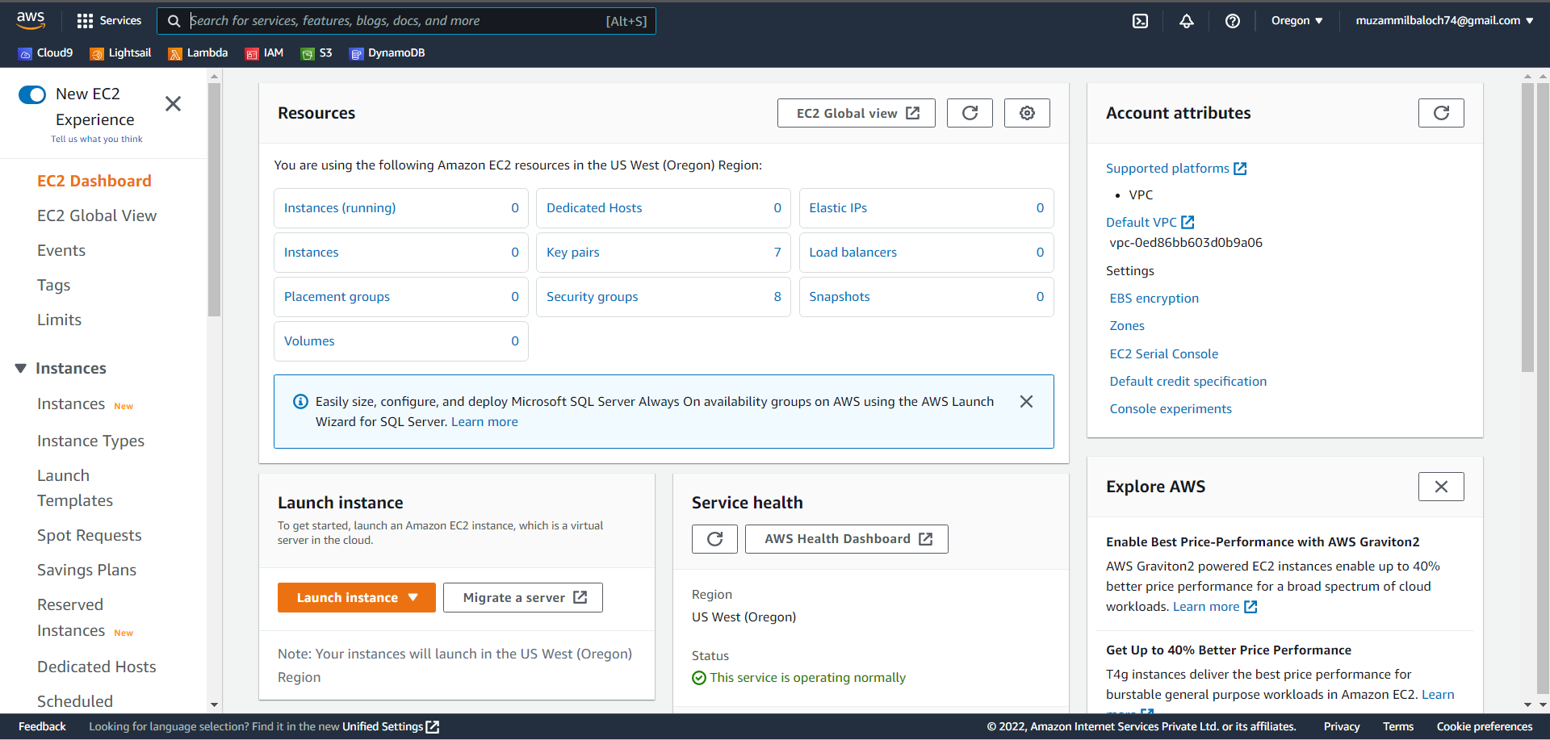

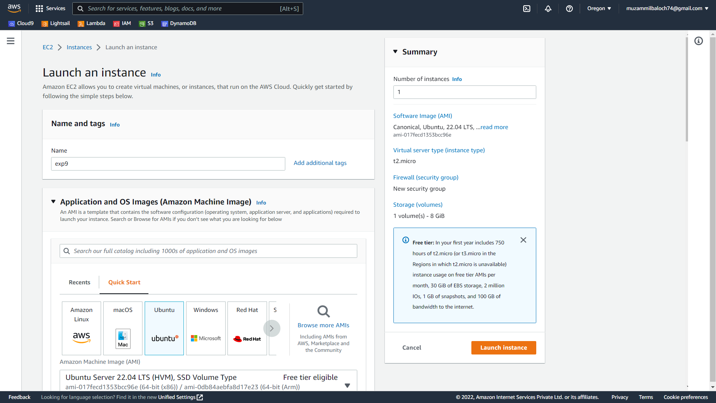

Step 2: Connect to the instance using MobaXterm.

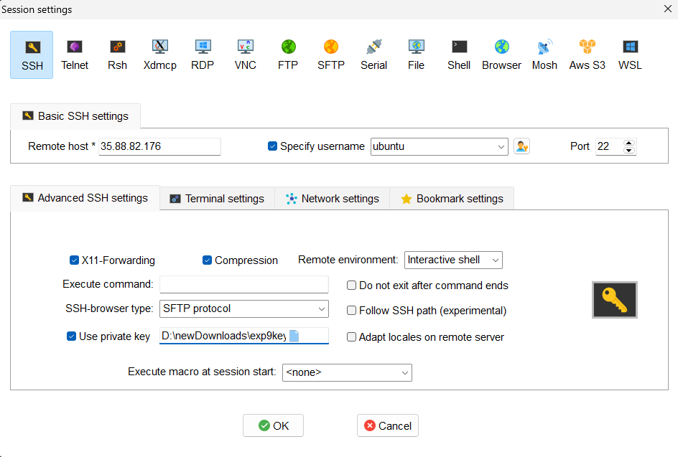

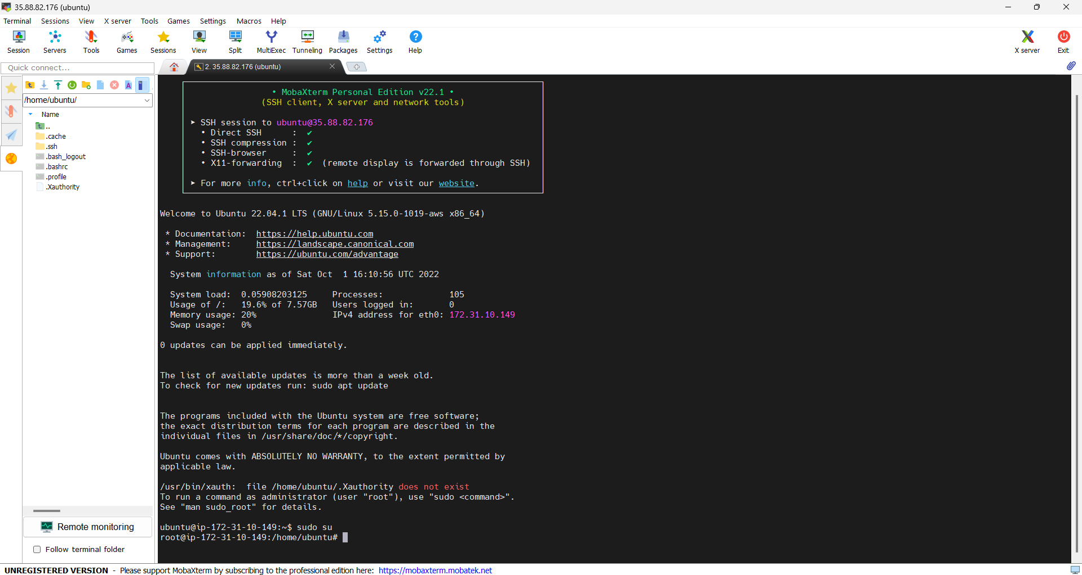

Step 3: Run the following commands in order to install docker.

#curl -fsSL https://get.docker.com -o get-docker.sh

#sh get-docker.sh

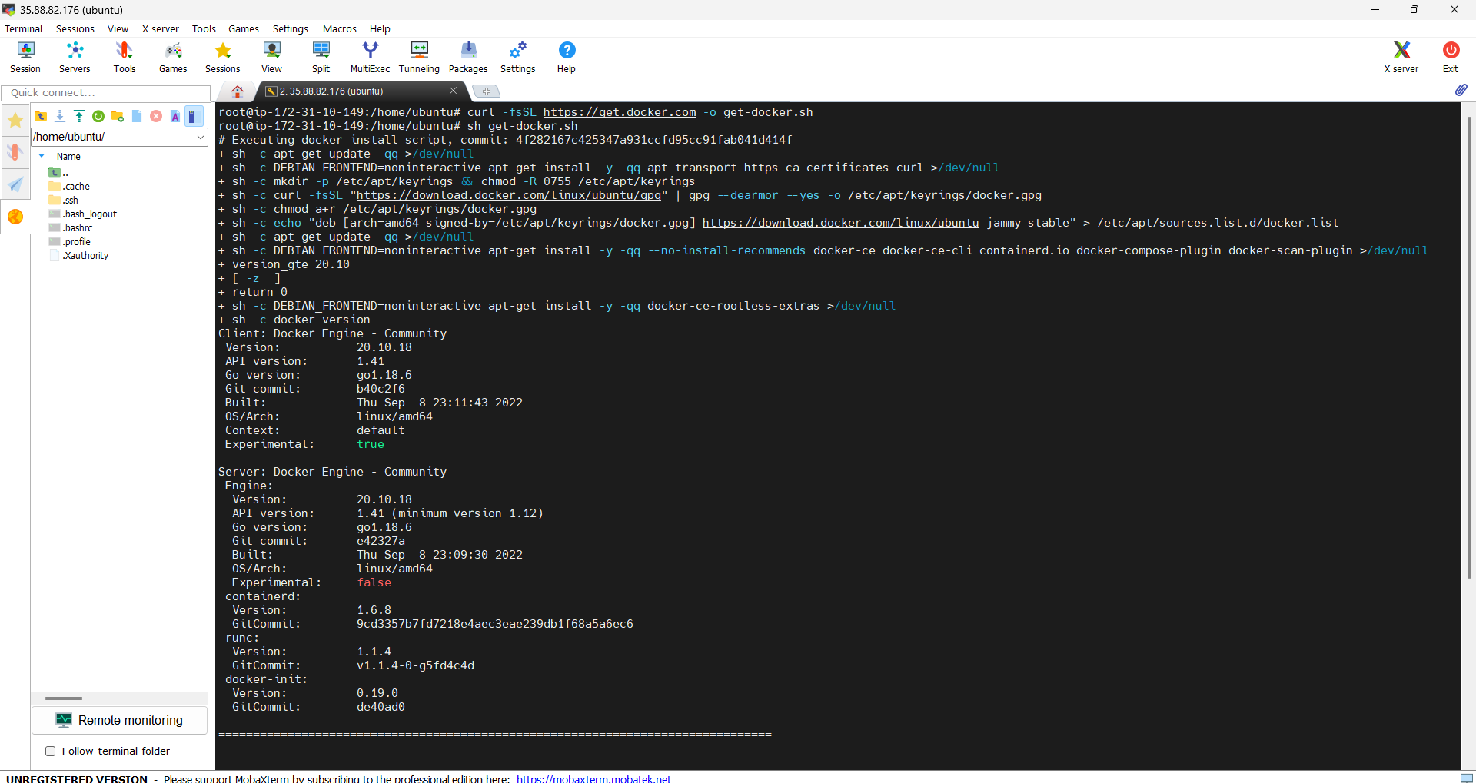

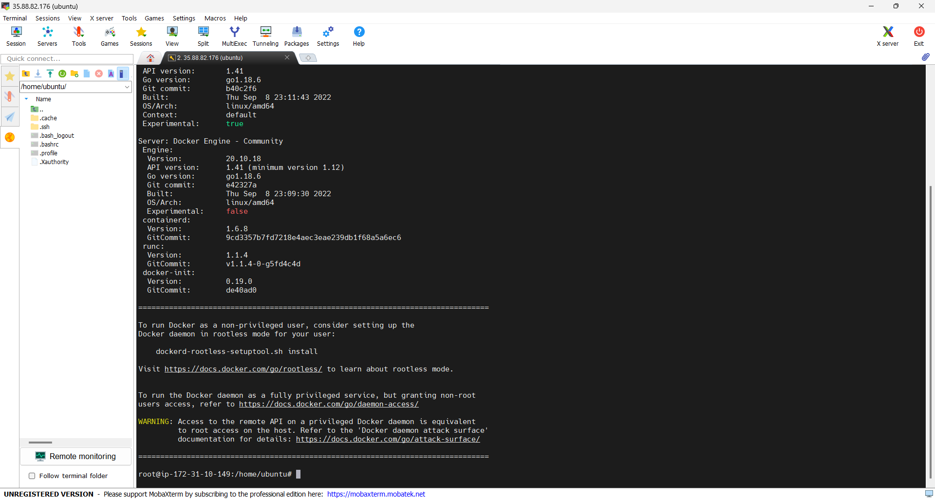

1. **Run a Flask Application inside a Docker Container and explain the steps.**

Step 1: Make a folder with your name, then make a file called app, and then add the code supplied inside app.py using nano.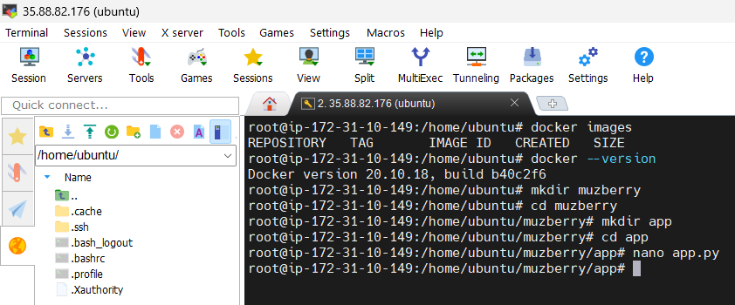

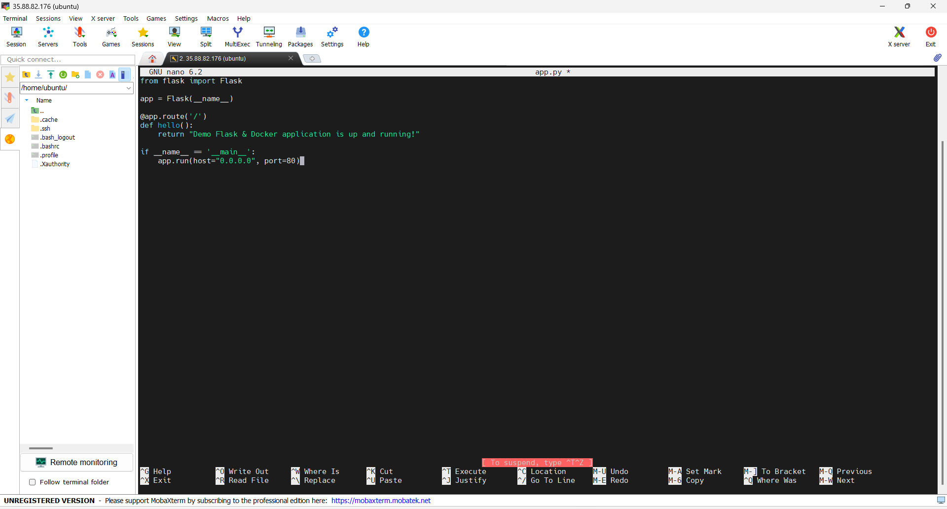

Step 2: Create a requirements.txt file with nano editor.

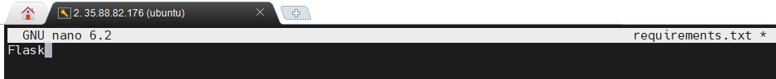

Step 3: Navigate to the parent folder and create a file called Dockerfile. And then, using nano editor, paste the code from the classroom.

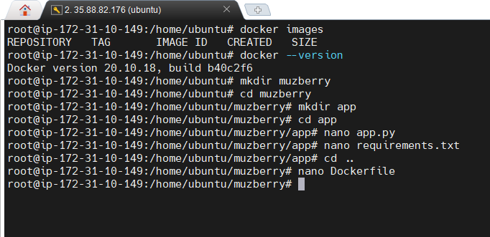

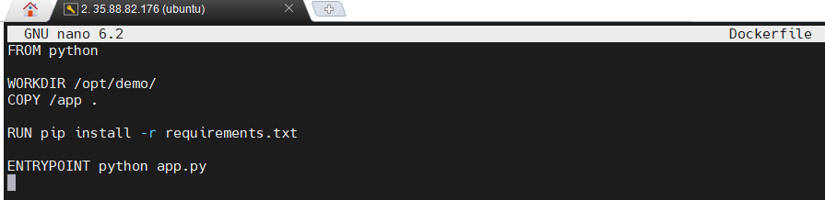

Step 4: i) Now run "docker build -t [file name]:latest .".

ii) Now, run the command as "docker images" to check the images.

iii) Run the command "docker run -d -p 80:80 [directory name]".

i)

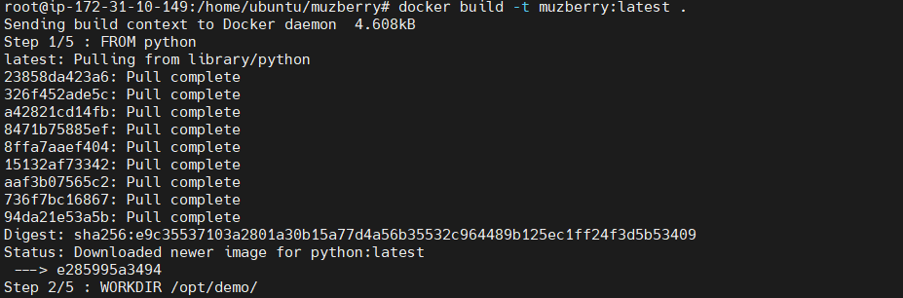

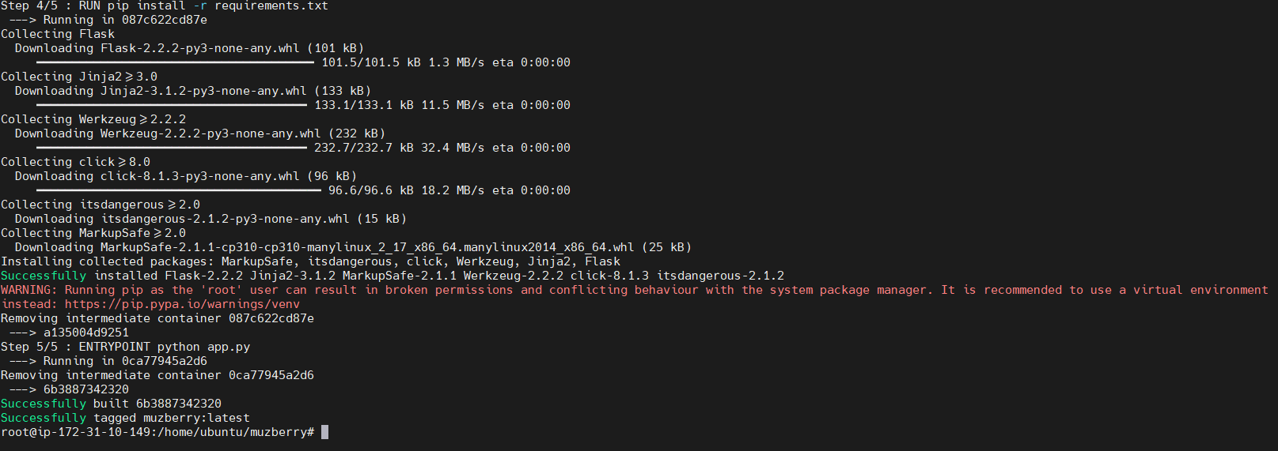

ii)

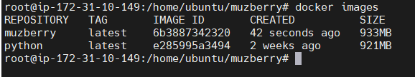

iii)



Step 5: i) To run the above command, copy the Public IPv4 DNS.

ii) Paste it in the Address Bar

i)

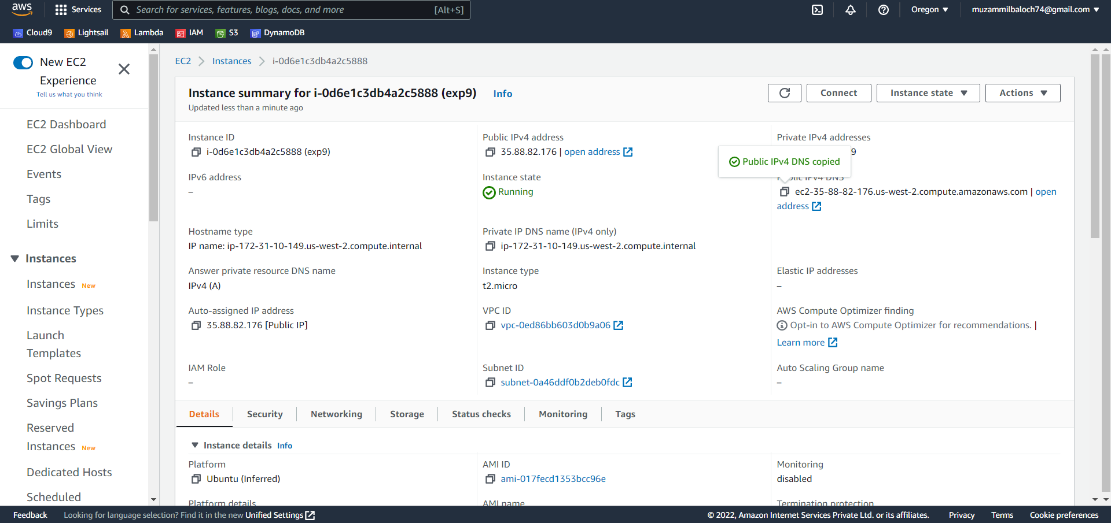

ii)

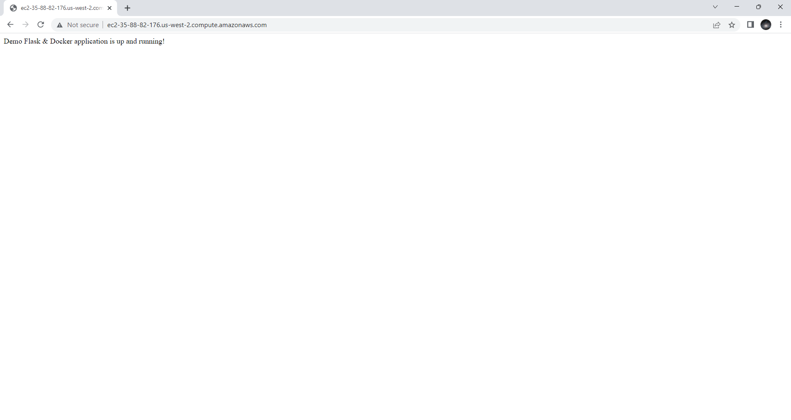

Step 6: Terminate the EC2 instance

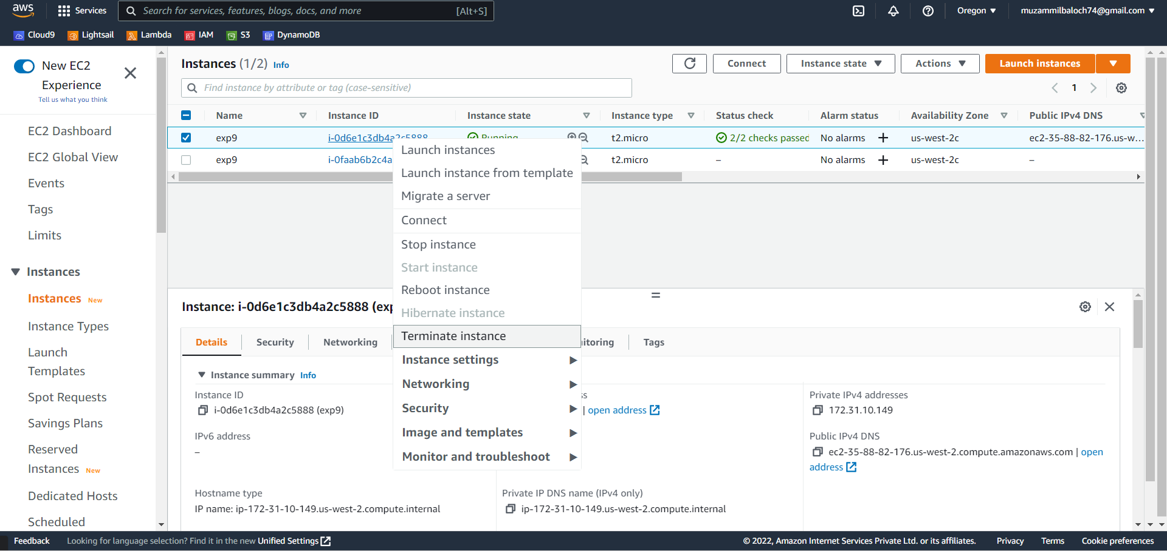

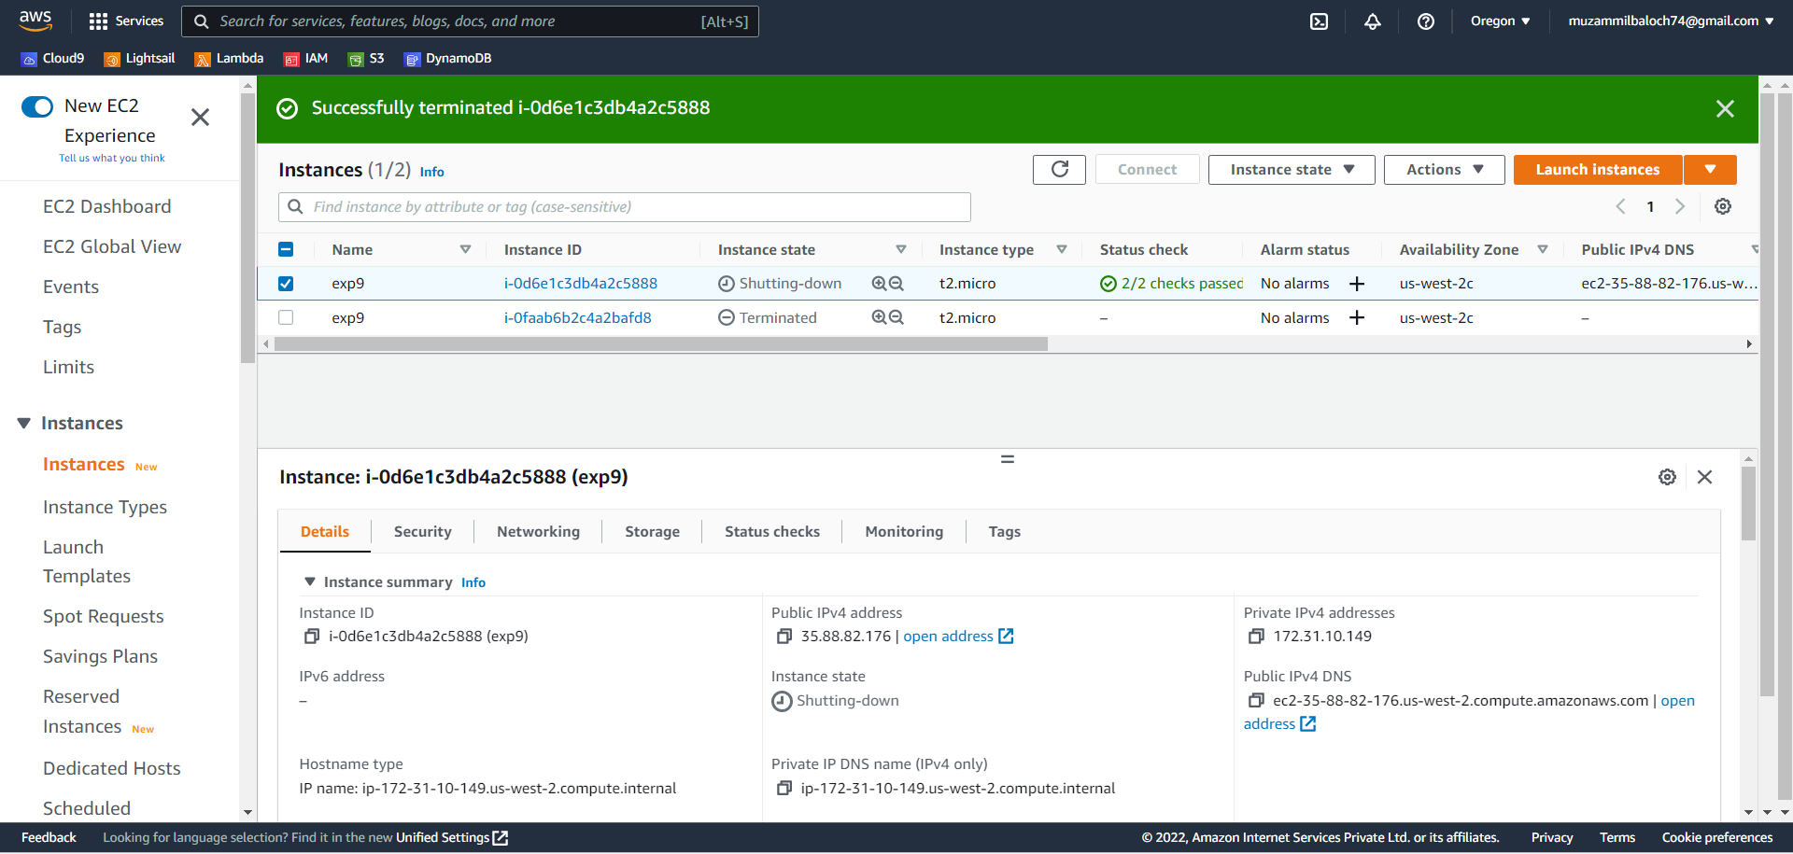

1. **What is Docker file? Explain all lines of your Docker file.**

Ans: Docker can automatically construct images by reading instructions from a Docker file. A Docker file is a text document that contains all of the commands that a user could use to create an image from the command line. Users can use docker build to create an automated build that runs numerous command-line instructions in sequence.

All of the lines in your Docker file are explained as follows:

• FROM python / The Base Image is specified.

• WORKDIR = /opt/demo/ It establishes the Working Directory for subsequent instructions.

• COPIED /flaskProject. All files in the flaskProject directory are copied to the current directory.

• execute pip install -r requirements.txt It will install all of the dependencies listed in the requirements.txt file.

• ENTRYPOINT / python app.py It will execute the app.py script in our container.